How to change Windows update settings on Windows 10

- Type “windows update” into the search bar.

- Click on “Windows Update settings.”
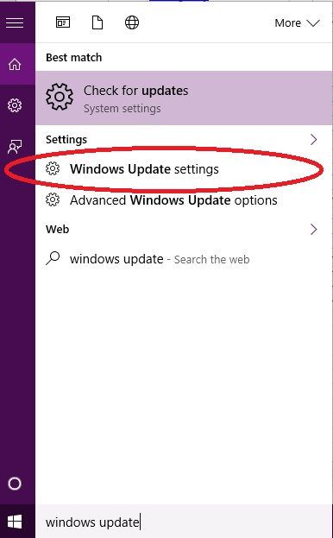

- Click on “Advanced options.”
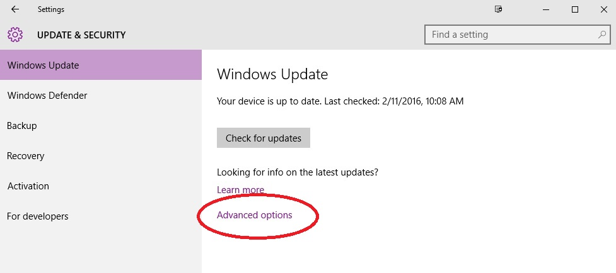

- Click on “Choose how updates are delivered.”
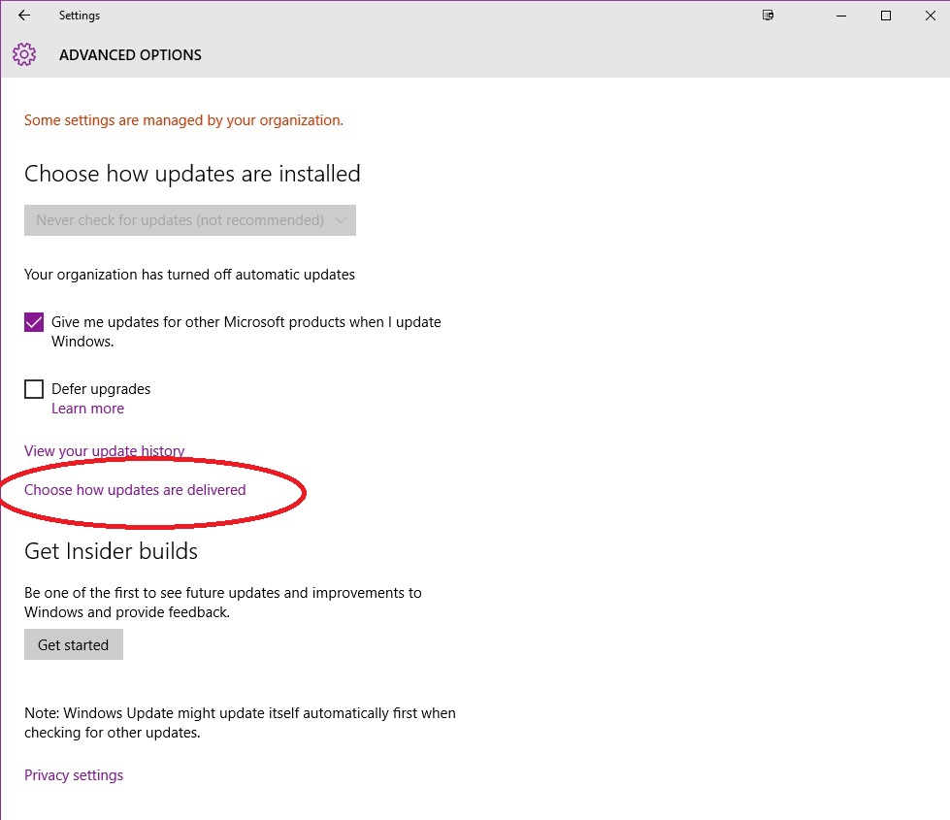
- Choose “PCs on my local network” or “Off” on this screen.
